GSM MODEM:

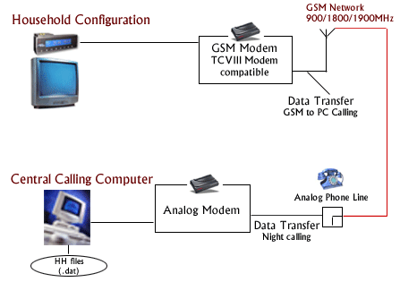
A GSM modem is connected to each Telecontrol unit. The central server calls up each of the Telecontrol units in sample homes to pick up the data stored therein. aMap's technology architecture enables instant data collection from the sample homes as often as desired. It also enables conducting of instant opinion polls about the programs being telecast. The collected data is instantaneously incorporated into the aMap reports.
At present the central server calls up all the sample homes between 2:00 AM and 4:00 AM IST (Indian Standard Time) to collect the data. In case the data from some of the homes/ units can not be collected in the first attempt, the server dials that home again after 5 minutes, and makes the third attempt after 1.30 hours. After 3 trials, the server gives up. If non-collection of data is caused by the problems with cellular connection, the data can be collected later at any time over next seven days.
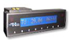
The system generates a list of sample homes from which the data could not be collected. These failures are investigated on the same day. The possible causes of failure in data collection are
- The Telecontrol power failure
- The Telecontrol unit disconnection/dysfunctional
- The sample home being locked
- The problems with cellular connection etc.
The Telecontrol system can respond to every possible use of a television screen, including viewing videos, playing TV games and using Teletext. Moreover, the design of the Telecontrol unit and its interactive system can be adapted to the psychological requirements of the panel household members, a key reason for its very high degree of acceptance and the widespread willingness to enter information.

GSM SPECIFICATION:
Before looking at the GSM specification, it is important to understand the following basics terms.
- BANDWIDTH: The range of channels limits, the border the bandwidth, the faster data can be sent.
- BITS PER SECOND (BPS): A single on – off pulse data, eight bits are equivalent to 1 byte.
- FREQUENCY: The number of cycles per unit of time frequency is measured in hertz (hz)
- KILO: Kilo is the designation of 1,000; the abbreviation kbps represents 1,000 bits per second.
- MEGAHERTZ: 1000000 hertz (cycles per second)
- MILLISECOND: one thousandth of a second.
- WATT (W): a measure of power of transmitter.
- frequency band : the frequency range specified for gsm is 1850 to 1990 MHZ (mobile station to base station)
- duplex distance: the duplex distance is 80 MHZ. duplex distance is the distance between uplink and downlink frequencies. A channel has two frequencies, 80 MHZ apart.
- channel separation: the separation between adjacent carrier frequencies. In gsm it is 200 khz.
- modulation: modulation is process of sending a signal by changing the characteristics of carrier frequency. This is done in gsm ie (GMSK) Gaussian minimum shift keying.
- transmission rate: gsm is a digital system with an over – the – air bit rate of 270 kbps.
- access method: gsm utilizes the time division multiple accesses (TDMA) concept. TDMA is a technique in which several different calls may share the same carrier. Each call is assigned a particular time slot.
- speech coder: gsm used linear predictive coding (LPC). The purpose of LPC is used to reduce the bit rate. The LPC provides the parameters for a filter that mimics the vocal tract. The signal passes through this filer leaving behind a residual signal. Speech is encoded in a 13 kbps.

